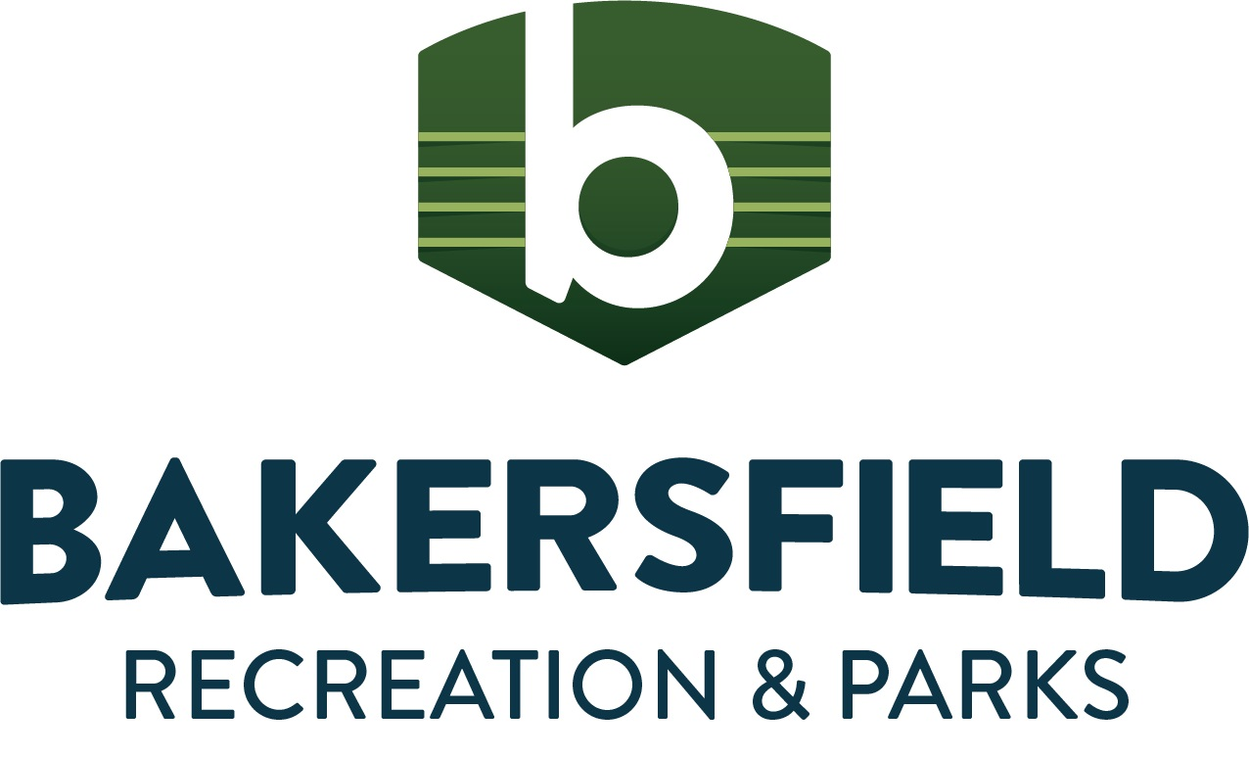Course Name: Pee Wee T-Ball Ages: 3-5
Equipment: Bats, Balls, Bases
Notes:

Day 1 | Day 2 | Day 3 | Day 4
Welcome players (3 min)  Review names (players & coaches)  • focus on (fun, try hard, teamwork) | Welcome players (3 min)  Review names (players & coaches)  • focus on (Everyone Makes Mistakes) | Welcome players (3 min)  Review names (players & coaches)  • focus on (Winners Circles) | Welcome players (3 minutes)  Review names (Players & coaches)  • Focus on (Honoring the Game)
Drill Sequence (13 min)  Ball Tag  • Players run in the infield while the coach tries to tag them frozen with a ball, repeat in the outfield  • The first round of this freeze-tag style game is played in an open field.  • The second round is played only using the fair territory of the field.  • In the third round, when the players are tagged they not only freeze, but they freeze in the position of a batter. | Drill Sequence (7 min)  Statues Freeze  •Players are tagged and must freeze like whatever the coach says.  •Players stay in the infield and freeze like statues when instructed by the coach.  • In the second round, the coach tags the players to freeze instead of just calling out “freeze.” | Left, Center, Right Field (10 min)  • The players begin in left field. Players run to each position when instructed.  (Use Color Place Mats)  • Once the game begins, the coach can call out a position at any time, even if the players are running between positions.  Grip and Throw (5 min)  • Discuss proper grip and the correct way to make throws.  • Coaches demonstrate the proper grip on the ball with fingers on top and the thumb underneath. | Clean Up the Backyard (8 min)  • Using a row of cones to divide as a boundary, players are divided into two teams.  • Squishy/light balls are scattered among both sides.  • On the word “go” players will pick up and throw the balls to the other side. The team with the least number of balls on their side after 1–2-minute wins.  • Before repeating game, mix up players and make new teams to give everyone a winning chance.  • Coaches, encourage good sportsmanship.
GRIP (3 min)  Players gather in a circle  • Grip the ball with the whole hand using fingertips.  • Have each player demonstrate the correct grip before going to spots to throw.  THROWING (12 min)  Demonstration (Coaches)  • Coaches focus on grip  The players practice throwing following the coach’s cues.  • Call players back to coach and teach stepping with the opposite foot (demonstrate)  • Call players individually to practice throwing. (Use Pitching Screen) | REVIEW GRIP AND THROWING (5 min)  • Players gather in a circle.  • Grip the ball with the whole hand using fingertips.  • Demonstrate correct grip and throwing with the opposite foot.  DRILL SEQUENCE: Target Throwing (15 min)  Players are grouped into teams. On “go” the first player from each team begins by throwing their ball at a target. The goal is to aim the ball as close to the target. Coaches monitor for grip and stepping with opposite foot.  (Use Pitching Screen) | Position Fitness (10 min)  Discuss outfield positions and infield positions. (Use Color Place Mats)  • Walk to each position and perform an exercise at that position.  • Talk about playing games and staying in position.  The players and coach begin at home plate. The coach announces the position, and then he or she demonstrates an exercise for the players to complete. Players and coach  complete repetitions of the exercise together before moving on to the next position and exercise. | Fielding (10 min.)  Drill sequence:  -Discuss “ground balls”  • Place 2-3 cones spaced out and divide the team evenly. Have players stand in lines behind the cones.  •Coaches will throw and roll the ball to the player at the front of the line.  •That player must find the ball and throw it back to the coach before going to the back of the line.  • Repeat until all players have practiced picking up and throwing a ground ball.
Break (4 min) | Break (4 min) | Break (4 min) | Break (4 min)
RUN THE BASES (8 min)  Following the coach, the players run/jog around the bases while calling out each base that they touch.  • For round two, the players will advance to each base one at a time and will stop on each base. They will move to the next base when they are cued.  • An option is to have a coach with a ball in his or her hand ready to tag players who come off of the base. | SWINGING (10 min)  Demonstrate a swing.  • Have players practice swinging without a bat (a dry swing)  • Take each player, one at a time to practice with a tee while others are still dry swinging. | Swing And Run (10 min)  Review the basics of swinging.  • Have players line up at home plate.  • Have each player take a practice swing and run to first base. Players advance one base at a time as the next player runs to first base.  Throwing (12 min)  • The players play catch with a partner.  • Practice fielding a ground ball  Switch partners as needed. | RUN THE BASES (8 min)  • The coach will lead the players in a run/jog around the bases while calling out each base that they touch.  • For round two, the players will advance to each base one at a time and will stop on each base. They will move to the next base when they are cued.  • Optional: Have a coach with a ball in his/her hand ready to tag players who come off of the base. This teaches players that bases are SAFE.  TEE HITTING (10 min)  Review how to hold the bat and swing  •Have players line up and practice hitting baseballs off the tee.  Parents help their kids.
CONCLUSION (2 min)  High fives, Review what they learned.  Remind Players next practice/game. | CONCLUSION (2 min)  High fives, Review what they learned.  Remind Players next practice/game. | CONCLUSION (2 min)  High fives, Review what they learned.  Remind Players next practice/game. | CONCLUSION (2 min)  High fives, Review what they learned.  Remind Players next practice/game.

Day 5 | Day 6
Welcome players (3 min)  Review names (players & coaches)  • focus on (TRYING HARD) | Welcome players (3 min)  Review names (players & coaches)  • focus on (WAG) W is for Watch. A is for Ask. G is for Get coaching.
Red Light, Green Light (6 min)  • Balls are lined up at right field. Players line up on the 3rd base foul line in the infield. The coach will stand on first base and call “green light” for players to run, “red light” for them to stop while players make their way to the balls. Once players reach their ball, they will continue to run towards their coach on first base. The player who tags the coach first wins.  Catching Practice (5 min)  The players find a personal space anywhere in the playing area. The players should all have his/her glove and ball.  • Players toss the ball in the air to themselves and catch it, or “squeeze it,” in their gloves | ZIGZAGGING- Warm up (5 min)  • Players are broken into lines and zigzagging around  their cones  The players are broken up into groups.  • On “go”, the first player in each line zigzags through the cones, circles around the last  cones, and zigzags back between the cones. They then tag the next person in line to proceed through the cones.  • Finish when all players are complete or turn the drill into a race between teams.  Offense and Defense “Play a game” vs Parents (20 min)  1. Separate kids and parents into two teams  2. Switch defense and offense after everyone has hit.
Break In Between (4 min) | Break In between (4 min)
Stations (30 min.)  • The players are broken into 3 stations.  • Station 1:  Practice Throwing – Players practice throwing with a partner. Then the players all stand behind the foul line and are prompted to all throw at the same time as far as they can.  • Station 2:  Practice Swings – Players practice swinging with a bat. Then players take turns swinging at a ball off of the tee.  • Station 3:  Call players individually to practice throwing. (Use Pitching Screen)  The stations rotate every 10 min. | Pop-Ups (10 min)  • Players are in groups, each group is in a semi  circle, players are tossed pop-ups and called by  name, the player calls the ball.  • Progress with difficulty  • How many can each player catch in a row  • Jumping jacks for the number of catches  Run The Bases Relay (8 min)  Divide players into two teams  • One team begins at home and the other team at  second base  • Players run one at a time with a ball as a  baton, and hand off once they run the entire circle.  • First team to finish wins
CONCLUSION (2 min)  High fives, Review what they learned.  Remind Players next practice/game. | CONCLUSION (2 min)  High fives, Review what they learned.  Remind Players next practice/game.

